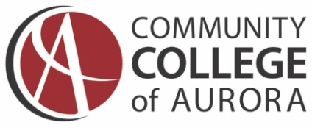

COMMUNICATIONS PLAN FOR:
Guided Pathways to Success
November 1, 2017
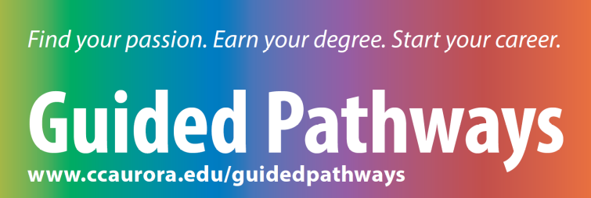

Purpose
The purpose of this plan is to outline the communications tactics and timeline for CCA’s Guided Pathways to Success program. The plan includes the most cost-effective communication tactics that will appeal to internal target audiences. Ongoing communication will help students understand the importance of a guided pathway to achieving their degree in a timely manner.

Background
Guided Pathways is an approach to degree completion that guides students on a clear path of classes so that they can spend less time wandering through unnecessary classes so that they can graduate on time and save money while doing it.

The Community College of Aurora’s program, Guided Pathways to Success, encourages students to pursue their career interests through six structured pathways to degree completion. The program helps reduce the number of undeclared students and increases those students identifying a degree with designation. Ultimately, the college believes its graduation and transfer rates can increase by implementing a successful guided pathways program.

CCA developed six guided academic pathways that are based on common interest areas to help students understand how their interests, personality traits, skills, and abilities lead to specific programs and careers. Academic course maps provide degree-specific curriculum information and sequence of courses students need to take each semester to complete their degree. Guided Pathways to Success, is CCA’s entire package of academic pathways, programs, advising, and other support services that get students from application to graduation.

Audiences
Primary: Students
- New students to CCA.
- Current/returning students to CCA.

Secondary:
- Full-time faculty, adjunct instructors
- Staff (library, registration, student lounge at Lowry)
- Concurrent counselors (external)

Communications Goals
The primary goals for this plan are to (1) increase awareness and understanding about the Guided Pathways to Success program and to (2) reduce the number of undeclared students while increasing the number of declared and degrees with designation.
KEY MESSAGES
- Encourage students to pursue their career interests and take classes to completion.
- Research shows that student will graduate faster, on time, spending less money if they are on a path.

The tagline that will be used for this program is:
Find Your Passion. Earn Your Degree. Start Your Career.
A unique URL has been created for this program:
www.ccaurora.edu/guidedpathways

Communications Tactics
- Email (internal audiences)
- Newsletters (Fox Times, Campus Connection)
- Bathroom Stalls (flyers on doors)
- Brochure
- Website
  - CCA homepage (image slider)
  - Blog on home page
- Posters and Flyers (also tailored for high school classes and advisors)
- Banner (welcome area at both campuses)
- Social Media
- Mobile App (TBD)
- Text Messaging (TBC)
- Question & Answer Sheet
- Desktop Computer Image
- Retractable Banner
- Meetings & Events
  - Student Orientations
  - All-College
  - Advising Department Meetings
  - Student Affairs Meetings
  - SPSS Chairs Committee
  - Workforce Center Meetings
  - School of Liberal Arts Chairs Meetings
  - Semester Kickoff (August)
  - Tables at CTC and Lowry Campuses
  - Advising Happy Hour
  - Come Back to Complete (event)
COMMUNICATIONS TIMELINE
Start: October 30, 2017 End: Nov. 10, 2017

What | When | Who
Email to Staff, Faculty, Students  - Message 1: Guided Pathways Site Now Open  - Message 2: How to Use Guided Pathways | - Week of 10/30  - Week of 10/30 | J. Florkowski  T. white
Email to Concurrent Enrollment Counselors  - Message 1: Guided Pathways Site Now Open  - Message 2: How to Use Guided Pathways Tools | - Week of 11/2  - Week of 11/2 | S. Beauchamp
Newsletters  - Fox Times  - Campus Connection (Sept. issue) | Week of 10/30  COMPLETED | J. Florkowski  A. Romero
Bathroom Stalls (flyers on doors) | Week of 10/30 | Student Life  C. Butler
Brochure  (orientations, advising offices, dept. chairs) | COMPLETED
Website  - CCA home page (image slider)  - Blog on home page | Week of 10/30 | J. Florkowski
Posters  - CCA (20) – Advisor’s Offices  - Concurrent Enrollment Classrooms | Week of 10/30  COMPLETED  ON HOLD | - Romero  T. White
Flyers/Handbills (distribution to faculty for classes) |  | T. White  A. Romero
Signage (banner at welcome centers) | COMPLETED | - Romero  T. White
Social Media Posts | November 1-10 | K. Dorame
Events, Meetings, Presentations  - Welcome Week | Monday Mixer  - New Student Orientations  - All-College Meeting  - Advising Department Meetings  - SLA Chairs Meetings  - Student Affairs Meetings  - SPSS Chairs Meeting  - Workforce Center Meetings  - Table Tents (A. Romero) | Aug. 21  Ongoing  Sept. 13  TBC  TBC  TBC  TBC  TBC  TBD
Desktop Image/Messaging | Week of 10/2 | J. Florkowski
Question and Answer Sheet | COMPLETED | T. Ward

MEASUREMENT
Key metrics for the tactics recommended in this plan are:
- Emails – number sent; opens
- Newsletters – clicks on stories
- Flyers, brochures, posters – number distributed
- Events, meetings, presentations – attendance
- Social media engagement:
  - Facebook, Instagram – number of Likes
  - Twitter – replies, retweets, mentions, or likes
- Website – number of clicks on unique URL
BUDGET
Budget for the printing of collateral materials will be charged to the Dean of Students. These materials include: flyers, posters, brochures. Layout and design will be handled by Communications and Marketing Department staff.

Guided Pathways Communications Committee
Tamara White Committee Co-Chair: Dean – Student Affairs
Mary Meeks Committee Co-Chair: Director – Communications and Marketing

Stephany Beauchamp Academic Program Coordinator - Concurrent Enrollment Office
Courtney Butler Academic Support Specialist – SPSS
Joe Florkowski Web Content Specialist
Phoebe Lassiter Pathways Advisor

Guided Pathways Program
Questions & Answers

KEY MESSAGES
These Key Messages are intended to be a resource to help communicate to students, faculty, and staff about the Guided Pathways program at CCA:
- Encourage students to pursue their career interests and take classes to completion.
- Research shows that student will graduate faster, on time, spending less money if they are on a path.

QUESTIONS AND ANSWERS (Q & A)
This section is an internal tool to help answer common questions from staff, faculty, and students about the changes in the Advising Department.

Q: What is the Guided Pathways program at CCA?
A: The idea behind guided pathways is that college students are more likely to complete a degree in a timely manner if they choose a program and develop an academic plan early. The Guided Pathways model at CCA is an intrusive advising model that helps students identify pathways to success.

Q: Why is CCA implementing the Guided Pathways model?
A: We are implementing a guided pathways model to increase retention and completion among students. We can help students create easily identifiable pathways to help them achieve their end goal.
Q: What are the benefits to CCA students?
A: Students who follow a guided pathways model of advising are more likely to save money and reach completion on-time if not earlier.

Q: Will there be an online component to the Guided Pathways program and when will it be available?
A: Yes, we expect the on-line version to launch in early November.

Q: How will the new CCA Navigate initiative affect Guided Pathways at CCA?
A: Guided Pathways and CCA Navigate work together. Think of Guided Pathways as the umbrella and CCA Navigate as another advising tool for students to use.

Q: How does it work?
A: Students log on to the Guided Pathways tool and are asked a series of questions to help guide them to information that will help them with academic course maps and advising.

Q: How can I help students with Guided Pathways?
A: If you are CCA staff, faculty, or an instructor and you learn there are some students who have not decided what degree they want to choose, forward them to the Guided Pathways website. You can also give them a flyer that explains how to get to the website.
The website is: www.ccaurora.edu/guidedpathways

Q: Who is the contact for more information about Guided Pathways?
A: Tamara White, Dean of Students | 303-360-4746

Professional Studies, STEM, Health & Public Service, People, Societies & Ideas, Communication and Languages, Creative Industries.
To be determined.
To be determined.
Community College Research Center, Research Overview, March 2015.

